ST. XAVIER’S COLLEGE

**Affiliated to Tribhuvan University**

Maitighar, Kathmandu

**SYSTEM DESIGN AND ANALYSIS AT NEXT AUSSIE TECH PVT. LTD.**

**A CASE STUDY**

**Under the supervision of**

**“Er. Rajan Karmacharya”**

**“Lecturer”**

Submitted by:

**Milan Rawal** (TU Reg. 5-2-282-75-2018)

**Bijesh Shrestha** (TU Reg. 5-2-282-64-2018)

**Nishant Bhurtel** (TU Reg. 5-2-282-77-2018)

Submitted to:

**ST. XAVIER’S COLLEGE**

Department of Computer Science

Maitighar, Kathmandu

March 2022



**CERTIFICATE OF APPROVAL**

The undersigned certify that they have read and recommended to the Department of Computer Science for acceptance, a case study entitled **“System Design and Analysis at Company Name”** submitted by **Milan Rawal, Bijesh Shrestha and Nishant Bhurtel** for the partial fulfillment of the requirement for the degree of Bachelor of Science in Computer Science and Information Technology awarded by Tribhuwan University.

……………………………..

Er. Rajan Karmacharya

Lecturer/Chief Technology Officer

Department of Computer Science and Information Technology

St. Xavier’s College

………………………..

Mr. Ganesh Yogi

Head of Department

Department of Computer Science and Information Technology

St. Xavier’s College

**ACKNOWLEDGEMENT**

First of all, we would like to extend our sincere thanks and gratitude to our respected Lecturer/Chief Technology Officer for System Analysis and Design, Er. Rajan Karmacharya for his continuous supervision, guidance and suggestions that helped us to accomplish the project successfully.

An honorable mention also goes to the Head of Computer Science Department, Mr. Ganesh Yogi for his understanding and supporting us in the completion of this project. We would also like to thank each and every staff member and other members of the Computer Science department for their direct/indirect contribution in this project.

Very special thanks goes to Mr., Nissan Pratap Jung Thapa,the Founder/CEO of Next Aussie Tech Pvt. Ltd and Nirmal Dangal, the CTO of Next Aussie Tech Pvt. Ltd for giving us his precious time from all the busy work that he has in order to help us answer the questions that we had about the company.

Finally, we would also like to thank everyone out there who stood by our side and supported us in completing this project.

Milan Rawal

Bijesh Shrestha

Nishant Bhurtel

**TABLE OF CONTENTS**

**CHAPTER 1: INTRODUCTION** **…………………………………………………………...1**

1.1. Background …………………………………………………………………………...1

1.2. About next Aussie Tech Ovt. Ltd.……………………………………………...……..2

**CHAPTER 2: LITERATURE REVIEW** **…………………………………………………...3**

**CHAPTER 3: RESEARCH METHODOLOGY** **…………………………………………...6**

3.1. Overview ……………………………………………………………………………...6

3.2. Methods Of Data Collection ………………………………………………………….6

3.2.1. Interview ………………………………………………………………………………...6

3.2.2. Questionnaire …………………………………………………………………...6

3.2.3. Record view and Background reading……………………………………………..7

3.2.4. Observation……………………………………………………………………………7

**CHAPTER 4: SYSTEM ANALYSIS AND DESIGN AT** **Next Aussie Tech** ……………..8

4.1. Overview of the development process ………………………………………………..8

4.2. Development Methodologies …………………………………………………………9

4.2.1. Agile Methodology ……………………………………………………...9

4.3. Planning and Analysis of a project …………………………………………………10

4.3.1. Requirement Gathering and Feasibility Study ……………………………….10

4.4. Designing the Project ……..…………………………………………………………11

4.4.1. Design Processes ……...……………………………………………………….11

4.4.2. Tools used …………...………………………………………………………...12

4.4.3. Database design ……………………………………………………………….12

4.5. Implementing the Project ……………………………………………………………13

4.5.1. Implementation Process ……………………………………………………….13

4.5.2. Programming Languages ………………………………………………………13

4.5.3. Testing …………………………………………………………………………13

4.6. Maintenance and Documentation ……………………………………………………15

4.7. Tools used …...………………………………………………………………………13

4.7.1. Git Version Control……………………………………………………………15

4.7.2 Own CRM (Customer Relationship Management) …………………………...15

4.8. Issues faced during a project ………………………………………………………...15

**CHAPTER 5: CONCLUSION** **……………………………………………………………..17**

**REFERENCES** **……………………………………………………………………………...18**

**LIST OF IMAGES**

**S.No. Description Page No.**

**1.** Image of interaction with CEO and CTO of the company 20

**2.** Image with CEO and CTO of the company 20

**CHAPTER 1: INTRODUCTION**

* 1. **Background**

This case study describes in details the process of System Analysis and Design **at Next Aussie Tech Pvt. Ltd.** The report contains a detailed description of each phase carried out during system Development Life Cycle (SDLC). A detail understanding of how System analysis and Designed is carried out in an organization was determined after interviewing the Chief technology officer (CTO) as of the organization.

The primary objective of this case study was to practically apply what we have learned during this semester course of System Analysis and Design. This case study helps us to identify a great difference between what we learned in our course and what information was known during this case study research was found.

Information and Data were derived from multiple sources like interviews and documents. A questionnaire was created regarding the study and an interview was conducted with the Chief Technology Officer (CTO) based on the questionnaire. This interview process provided us with most of the information needed to complete this case study research. Apart from the interview, some research on the company's history, objectives, and goals was also done to get a better understanding of what the company does and why it does certain things.

Mr. Nirmal Dangal, a Chief Technology Officer (CTO) at **Next Aussie Tech Pvt. Ltd.** Was interviewed to gather the necessary information required to completer this report. He is a professional with more than 6 years of experience working in the software industry. He talked about how he, as a CTO pro oversee and manage the company's project, and how the development process works at **Next Aussie Tech Pvt. Ltd.** He guides us through different phases and iterations a project goes through, the processes involved, the tools, and the methodologies used during a project.

**1.2 About Next Aussie Tech Pvt. Ltd.**

Next Aussie Tech is one of the flourishing IT firms that was established internationally in Australia in the year 2012. The company was established in Nepal in 2016, the firm has actively been grooming its paradigm in Information technology to date. Successful in serving up to 400+ clients on Software Development and 500+ clients on Website Development and Management on approximate, the firm has recognized itself as one of the potential IT outlooks in the digital industry of Nepal. Intending to build a bigger and greater digital Nepal, the firm has set its own benchmark in the growing IT field with the specializations and spectacular work history that remain intact and go hand in hand with the customer’s obligatory.

**Website:** nextaussietech@gmail.com

**Industry:** Software Development and Web Development

**Company size:** 30+ employees

**Specialization:** **NEXT AUSSIE TECH** offers the complete software development bundle to the clients who wish to consider the required subtleties and foundations for the development procedure, helping to completely mirror the technique on their business prospect. This company has been providing services to the clients of Australia and Nepal. The services provided by this organization include custom Software Development, School Management Software, Restaurant Management Software, Accounts Management Software, Payroll Management Software, Attendance Management Software, ERP Management Software, etc.

**Mission:** The Company’s mission is to rectify the hurdles that an individual or business undergoes when supplicating the mandatory IT requisites and direct them to acquire the absolute IT solution that the firm assures to the fullest.

**Vision:** The Company’s vision is to flourish the absolute IT solutions nationwide and entitle an individual or business to the beneficiaries that they can embellish and obtain the futuristic intents that go hand in hand at ease.

**CHAPTER 2: LITERATURE REVIEW**

Successful systems development is the heart of the information systems (IS) practice and, consequently one of the key concerns of the IS discipline. In recognition of the sociotechnical, rather than purely technological, nature of the systems build around information technology(IT), this field of study devotes much attention to the social, organizational cognitive and behavioral and aspects of systems and of their development processes.( Keng Siau, Roger Chiang, Bill C. Hardgrave, Systems Analysis and Design) [1].

A system owes its existence to one or more objectives all of which lead to the main or central objective that the system user desirers or wants to be fulfilled. Systems analysis and design is the process of studying the current system, analyzing the needs and problems, finding alternate candidate solutions, evaluating each of them separately, and finally choosing the “Best One”!.(Systems Analysis and Design, Goyal Arunesh) [2].

“Systems Analysis and Design” is problem solving using the systems approach totally/partially using computers. The main component are: system elements, processes and computer technology, thus, systems analysis is a customized tailored-made approach for problem solving with the help of computers.( Systems Analysis and Design, An Active Approach by George M. Marakas) [2].

The overall goal of System Analysis is to study procedural components and modules. The goal of System Designs to design whole software, which fulfills all the requirements of customer. This leads to improve organizational systems, by applying software, which helps employees to perform business, tasks more effectively. [4]. System Analysis is important because it provides an avenue for solutions in the system through the various tasks involved in doing the analysis. Through these various tasks, the overall quality of a system can be easily modified or improved and occurrences of errors can ultimately be reduced. [5]

System analysis is the way toward noticing the system for investigating or improvement purposes. It is applied to information technology, where computer-based systems need to be characterized for examination as per their makeup and plan. [6]

Thus, software engineering could be said to involve both analysis and design of a software system that addresses a specific task or problem domain and includes the elaboration of concept(s) which will later be constructed or developed into appropriate software system(s). According to Bennett et al. [7], the analysis describes the “what” of a software system, which means what happens in the current and what will be required in the new software system; this refers to requirement analysis or gathering. On the other hand, design describes the “how” of a software system; that is, how the system will be constructed. Thence, analysis and design make up the foundation upon which the information system―an integrated set of components that includes the software element―is built.

SDLC processes generally number at 6 distinct stages: planning, analysis, designing, development and testing, implementation, and maintenance. Each of them is briefly explained below.

1. **Planning:**

The planning phase of the SDLC is also when the project plan is developed that identifies, prioritizes, and assigns the tasks and resources required to build the structure for a project.[8]

1. **Analysis:**

The analysis stage includes gathering all the specific details required for a new system as well as determining the first ideas for prototypes. Developers may: Define any prototype system requirements, Evaluate alternatives to existing prototypes, Perform research and analysis to determine the needs of end-users. [9]

1. **Designing:**

This stage includes the designing of requirements specified in the very first phase of the SDLC. In addition to assisting in specifying hardware and system requirements, that stage also helps define the overall software architecture.[10] The system design specifications prepared in the designing phase serve as the input for the next i.e. fourth stage of the SDLC. During the designing phase, testers are required to form an apt testing strategy. It contains what needs to be tested, and how it needs to be tested.

1. **Development & Testing:**

1In the development phase, the developers start working on the actual project. They develop the code from scratch using the design specifications given in the DDS. In most cases, testing remains a consistent part of the project throughout the SDLC. Therefore, it is always involved in SDLC in some way or another, regardless of which phase you are currently in. [11]

1. **Implementation:**

This phase is initiated after the system has been tested and accepted by the user. In this phase, the system is installed to support the intended business functions. System performance is compared to performance objectives established during the planning phase. Implementation includes user notification, user training, installation of hardware, installation of software onto production computers, and integration of the system into daily work processes. This phase continues until the system is operating in production in accordance with the defined user requirements. [12]

1. **Maintenance:**

Finally, there’s the maintenance phase, which occurs over time after the product has been released. This phase deals with dealing with problems experienced by the customers/end-users while using the software. [13]

So, in conclusion, we can say that system analysis is a problem-solving strategy that includes glimpsing at the more extensive system, breaking the separated parts, and sorting out how it works to accomplish a specific objective. [14] SDLC in software engineering provides a framework for a standard set of activities and deliverables. SDLC in software testing consists of a detailed plan which explains how to plan, build, and maintain specific software. Hence, The Software Development Life Cycle (SDLC) is a systematic process for building software that ensures the quality and correctness of the software built.[14]

**CHAPTER 3: RESEARCH METHODOLOGY**

**3.1. Overview**

The research was conducted in order to study how System Analysis and Design is approached and used in any software development company. The objective of this case study is to enhance course participants’ understanding in the areas of software development. Finding out the advantages and disadvantages of these methodologies as well as learning how to effectively use them was also a part of the objectives. In order to fulfill these research objectives, the authors opted to obtain the view of someone who has been leading these kinds of projects for more than a decade. This chapter focuses on what methods of data collection were used to retrieve the most suitable information for this study.

**3.2. Methods of Data Collection**

**3.2.1. Interview**

Interviews on site were taken through communication with the Chief Technological Office of the **NEXT AUSSIE TECH**. Different questions related to system analysis and design was asked. The interview was conducted in the office room of the CTO. We had already plan in advance the type of questions that we are going to ask and the interviewer was also prepared to answer any type of questions,

**3.2.2. Questionnaire**

A questionnaire was prepared and provided to the company before the appointment. The questionnaire contained various questions about system analysis and design techniques used in the company. The questionnaire was created keeping in mind that it should cover all the phases of the SDLC life cycle. The contents of the questionnaire were thoroughly covered and then filled up with the details provided.

**3.2.3. Record view and Background reading**

Information related to system and organization was already available in document like brochures and it was also published in their website. Stud of already available document was the fastest and independent way of gathering facts and information.

**3.2.4. Observation**

Different rooms in the company was observed. The room of CEO, CTO, project managers, Developers and Testers was observed and visited in order identify how the work is done in the company.

**CHAPTER 4: SYSTEM ANALYSIS AND DESIGN AT Next Aussie Tech**

**4.1. Overview of the development process**

When the company gets a new project, first of all Initial meeting is done between product owner, who is leading the meeting, the development team, and the scrum master. The goal of this meeting is the answers all the questions of the clients, and listens to what the requirements and goals are for the project. In the end of the meeting, a short proposal for the client project is prepared which contains every detail about the project like the functional and non-functional requirements, the expected outcomes, the acceptance criteria, the time required to complete the project, the number of persons involved, etc. with specifications.

The scope of work (SOW) document is prepared after the meeting. This involves project manager and a Solution Architect in order to get a complete understanding of the project’s requirement, deliverables and goals. A detailed specification is developed in order to ensure client get what they need for the first time. This features a description of what the application will do and how it will work, along with a definition of any data that needs to be stored. This is the critical piece of the project, when all of the ‘hard thinking’ is done, and is charged according to time spent. Next, a cost-benefit analysis is carried out to help you priorities which features should be built-in from the start. Once this is completed, we design all the screens so that you can ‘walk through’ them and see what you are getting before the product actually built. This helps us ensure we have understood exactly what you need before we build it.

After the SOW document, the architecture of the project is then laid out by system architecture. Before moving on to building, a review is undertaken involving all major parties to double-check that all goals and requirements are being met. This is done at a fixed cost, based on the specification agreed in Stage 2. Then, the project manager creates a schedule for the project and assigns roles to everyone involved. Then the product is developed iteratively and in sprints of two to three weeks which involved different developers.

After the final product is ready, the internal testing is done. This is the testing phase in which the application will go two rounds of testing by our in-house team before being sent through to you for your approval. The stage consists of a small number of users running through all the features of the application and providing us with feedback, which we use to make the last minor modifications.

After internal testing is completed Acceptance Testing is done. In this stage an application will be deployed onto the client’s environment for end user acceptance testing. A bug tracking tools is used to track all the issues and deploy updated version as per the fixes. Once acceptance is completed we will deploy the application to production environment.

After the acceptance testing is done, Product Support is provided to the user. During this phase, Innovate provides free support for six months. Additional support options are also available either by monthly fixed price based on time and material. The Delivery managers will be in touch with the clients regarding various options.

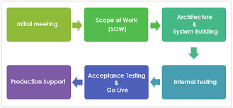

**4.2. Development Methodologies**

Next Aussie Tech Pvt. Ltd. generally focuses on using the Object-Oriented approach of System analysis and design. Because the implementation is also done using the Object-Oriented method and it have lots of benefits like modularity for easier troubleshooting, reuse of code through inheritance, Flexibility through polymorphism, Effective problem solving, etc.

**4.2.1. Agile Methodology**

Next Aussie Tech Pvt. Ltd. Uses agile methodologies to manage its projects. This methodology is the most preferred methodology by the company. This methodology has been in used since 1.5 years. According to the CTO, it is very difficult to satisfy the clients in our country so in order to maximize the client satisfaction this methodology is adopted.

Agile is an iterative approach to project management and software development that helps teams deliver value to their customers faster and with fewer headaches. Instead of betting everything on a "big bang" launch, an agile team delivers work in small, but consumable, increments. Requirements, plans, and results are evaluated continuously so teams have a natural mechanism for responding to change quickly.

Each iteration is considered as a short time "frame" in the agile process model, which typically lasts from one to four weeks. The division of the entire project into smaller parts helps to minimize the project risk and to reduce the overall project delivery time requirements. Each iteration involves a team working through a full software development life cycle including planning, requirements analysis, design, coding, and testing before a working product is demon The Agile method has gained momentum as a top choice for leaders and developers alike. And it’s no surprise why. It has Greater stakeholder engagement and collaboration. Agile encourages a high degree of input and collaboration between the client and development team. This leads to happier clients because there is transparency throughout the process and developers are better informed on client needs and wants.

It also has Predictable costs and scheduling. By breaking down the development process into iterative sprints, project managers can more accurately estimate costs and set clear, predictable timelines. This makes stakeholders happier because they know what to expect and can plan budgets and marketing strategies more precisely. It also makes the development process easier for teams because they can focus on delivering quickly and reliably and test software regularly for quality and efficacy. With the Flexibility amidst change agile project management is all about being nimble so teams can adapt to changes quickly while reducing sunk costs. Agile allows teams to pivot due to changing client needs, shifts in market demands, or in response to evolving product requirements. This gives teams the flexibility to refine and reprioritize the product backlog so that they are always delivering high-quality, relevant products on time and on budget.

It produces higher quality products .Agile product development integrates regular testing into the development process. This makes it easier for the product owner to identify any issues early on and make changes as needed. The result is higher quality products that are relevant and thoroughly vetted. Additionally, because Agile is more user-focused, Agile teams make decisions based on user stories, testing feedback, and client input throughout the process. This ensures that each feature isn’t just a functional IT component, but a valuable product for end-users. Together, these processes minimize risk and help teams deliver value more quickly, resulting in faster ROI started to the client.

**4.3. Planning and Analysis of a project**

**4.3.1. Requirement Gathering and Feasibility Study**

The requirement gathering is the first step. It is done through initial meeting between clients and the company different individuals. The company looks into all the possible factors that may cause the project to not succeed. Different feasibilities like economical, technical, operational, and scheduling feasibility is carried out. After the completion of feasibility, detailed document of its findings is prepared and provided to the client. The feasibility study is one of the most important part in this organization and it is carried for every project undertaken by a company.

**4.4 Design of a project**

Design is one of the most important part in the company. Transformation of all the requirements into detailed specifications covering all the aspects of the system is done in this phase. Since the company follows an object-oriented system design the class diagram is drawn for almost all the projects. Other diagrams like ER diagrams, use case diagrams, and even DFDs are drawn as per the requirement of the project or client.

**4.4.1. Design Processes**

In the designing process, the company creates the diagram as per the complexity and the necessity of the project. UML is a modeling language used since the company follows Object Oriented Software Design to provide a more detailed view. For the logical design, relation DB is prepared. A prototype of every design is prepared by UI/UX designer of the company.

**4.4.2. Tools used**

Different tools are used during the design phase. These tools are used to prepare a prototype of the design. There are three tools that are most preferred during the design phase. They are Adobe Photoshop, Figma and Adobe XD. Adobe Photoshop is software that is extensively used for raster image editing, graphic design and digital art. It makes use of layering to allow for depth and flexibility in the design and editing process, as well as provide powerful editing tools, that when combined, are capable of just about anything.[16] Adobe XD is a vector-based UI and UX design tool and it can be used to design anything from smart watch apps to fully fledged websites. Let’s take a look at what it offers designers and why it’s become such a powerful tool in the web design industry. [17] Similarly, Figma is a cloud-based vector graphics editor and prototype tool set up for collaborative and remote interface design. The UI software has all the resources you need for every step of a design project—even generating code you can export. Accessible via a web browser or app, Figma is a versatile program that can be used to design websites, apps, and many more digital products. [18]

**4.4.3. Database Design**

Database management systems are essential for organization because they offer an efficient way of handling large amounts and multiple types of data. The ability to access data efficiently allows companies to make informed decisions quicker. In this organization. Both SQL and NoSQL database is used.

SQL or the Structured Query Language is the most common and popular programming language for the relational database management system. It is a language designed to extract, store, insert, delete, update and manage data for structured data and strategic analysis.[19] NoSQL database provides a mechanism for storage and retrieval of data that is modelled other than tabular form. It was introduced by Carl Stroz in the year 1998 called a Non-relational database. Now, it stands for not only SQL. It is not limited to storing data in tables, instead, enables the big data to be stored in the structured, unstructured, semi-structured or polymorphic form. [20]

The SQL databases used in a company are MySQL and PostgreSQL whereas the NoSQL database used was MongoDB. The database used in a company is determined according to the type of project.

**4.5. Implementing the Project**

**4.5.1. Implementation Process**

The implementation process is done after all the requirements are clearly defined. This phase is initiated after the system has been tested and accepted by the user. The company assigns designers, developers, project managers, system analyst, QA testers, and all required personnel to work on the new project. The number of assigned people for each project is determined by according to the complexity of the project. The project can be of the duration 1 to 6 months.

**4.5.2. Programming Languages**

At Next Aussie Tech Pvt. Ltd., a wide range of programming languages are used. Usage of programming languages depends on the type of project and the requirements. The languages and their tech stack used in this organization are described below.

1. **PHP**: Due to the new possibilities it opens up on the Web, the php paradigm has received much attention. PHP is an open-source, interpreted, and object-oriented scripting language that can be executed at the server-side. PHP is well suited for web development. Therefore, it is used to develop web applications (an application that executes on the server and generates the dynamic page.)[21]
2. **JavaScript:** JavaScript is a scripting or programming language that allows the implementation of complex features on web pages. One of the more interesting developments recently gaining popularity in the server-side JavaScript space is Node.js. It's a framework for developing high-performance; concurrent programs that don't rely on the mainstream multithreading approach but use asynchronous I/O with an event-driven programming model [22].

JavaScript framework like React, vue and angular are used in Next Aussie Tech Pvt. Ltd. mostly for the front-end and for back-end nodejs is used to create the backend services on several projects.

1. **Flutter:** Flutter is a free and open-source mobile UI framework created by Google and released in May 2017. In a few words, it allows you to create a native mobile application with only one codebase. This means that you can use one programming language and one codebase to create two different apps (for iOS and Android).[23]

**4.5.3. Testing**

Software testing is the process of evaluating and verifying that a software product or application does what it is supposed to do. The benefits of testing include preventing bugs, reducing development costs and improving performance. Few can argue against the need for quality control when developing software. Late delivery or software defects can damage a brand’s reputation — leading to frustrated and lost customers. In extreme cases, a bug or defect can degrade interconnected systems or cause serious malfunctions.

Next Aussie Tech has been performing testing of its products by using mainly two ways. Manuel QA and Automation are mostly used. A separate QA team is responsible for testing and analyzing the product. It is performed to discover bugs in software under development. In Manual testing, the QA team checks all the essential features of the given application or software. In Automated Software Testing, testers write code/test scripts to automate test execution. Testers use appropriate automation tools to develop the test scripts and validate the software. The goal is to complete test execution in a less amount of time.

**4.6. Maintenance and Documentation**

After a project is successfully delivered to the client, the work is not finished. Many bugs and unseen issues can arise when the project is in production and actual users start using the service. There is a need to constantly maintain the project. Maintenance usually includes fixing bugs, updating databases, fixing security issues, updating packages, and tools used in the project, etc.

When there is a need to perform software maintenance, Next Aussie Tech plans ahead and schedules the maintenance work. Firstly, the project that needs maintenance is identified and the requirements are discussed. Out of many personnel working at the company, the project manager finds people that are not working on top priority projects and assigns them to work certain hours daily or weekly on that maintenance work.

Documentation is one of the most important aspects of any project. It’s always important to have reliable documentation to guide your work. If you are like most developers, you can be supporting multiple applications at the same time, which means that it is even more crucial to have documentation in place to help track all aspects of each application. It’s also helpful for development, maintenance, and knowledge transfer to other developers. The following are some areas in which documentation is especially valuable for a developer and some of my thoughts on what should be included. If possible, the documentation should be focused into the various components that make up an application.

**4.7. Tools used**

Completing a software development project requires using several tools that help at each phase of the process. Some tools among many used at Next Aussie Tech Pvt. Ltd. that help them deliver a project smoothly are described in this section.

**4.7.1. Git Version Control**

A version control system is a software that tracks changes to a file or set of files over time so that you can recall specific versions later. It also allows you to work together with other programmers. The version control system is a collection of software tools that help a team to manage changes in a source code. It uses a special kind of database to keep track of every modification to the code. Developers can compare earlier versions of the code with an older version to fix the mistake. Some key benefits of having a version control system are Complete change history of the file, Simultaneously working, Branching and merging and Traceability.[24]

**4.7.2. Own CRM (Customer Relationship Management)**

The CRM used by the company was made confidential from the other other expect the employees. CRM (customer relationship management) platforms are designed to help businesses manage their customer interactions and customer information by enabling easier communication and behavioral tracking.[25] A CRM platform helps companies target different audiences, set scores and alerts based on an individual lead or customer’s activity, proactively work with contacts, and maintain relationships. Best of all, a CRM system can be used across departments to ensure that all customer-facing teams are empowered with the right data to create incredible customer experiences.[26]

**4.8. Issues faced during a project**

According to Mr. Nirmal Dangal, most of the organizational issues they face are from the clients. The main reason behind issues is the expectations from the clients. When expectations are not met, the clients can raise issues and if these issues are not dealt with soon, they can turn into bigger problems. To prevent these kinds of issues, project managers ensure that requirements are clearly understood by everyone on the team.

Improper testing can also sometimes cause unwanted problems. In many cases, the tester may not have created proper test cases and may have not defined all the edge cases properly. With poor testing, a poor product is delivered which does not meet the client’s expectations.

**CHAPTER 5: CONCLUSION**

The software development life cycle can and is adapted by software development teams based on the philosophy, methodology and framework they adopt when building a given software product, or between organizations. Little, if anything, is written in stone, nor should it be. The SDLC is a tool in the project management box and should fit the needs of a particular project, the team working on it and other key stakeholders involved in the process. Phase names, their order, or if they are distinct or conflated into each other change.

After conducting this research and talking to someone who has been working as a lead in the software industry for over a decade, a vast difference was found between what was learned theoretically and what the practice in the current scenario was. Each company has its own principles and approaches when it comes to software development. The structured approach was studied in-depth during the course in System Analysis and Design; rather it was found that tech companies do not differentiate between Structured and Object-Oriented approaches but use the combination of both these techniques to complete their projects.

The methodologies have also evolved beyond what the syllabus covered. While the base of these models was still the same, methodologies like Scrum were being extensively used in combination with the agile methodology. This goes to show that rather than differentiating between these processes, the better parts of them work together to ensure the successful completion of a project. Hence, software development methodologies are not static but dynamic, they are being changed and evolved to match the current advancements in the industry and the need to deliver software that is fast and reliable in record time.

**REFERENCES**

[1] Systems Analysis and Design: People, Processes, and Projects By Keng Siau, Roger Chiang, Bill C. Hardgrave

[2] Systems Analysis and Design By Goyal Arunesh

[3] Systems Analysis and Design: An Active Approach by George M. Marakas

[4] UKEssays. (November 2018). Goals and Objectives of Systems Analysis and Design. Retrieved from https://www.ukessays.com/essays/computer-science/goals-objectives-systems-analysis-8056.php?vref=1

[5] Structured System Analysis and Design By J.B. Dixit

[6] AnalyticSteps.

What is System Analysis and Design?. Retrieved fro https://www.analyticssteps.com/blogs/what-system-analysis-and-design

[7] Mahalakshmi, M. and Sundararajan, M., 2013. Traditional SDLC Vs Scrum Methodology – A Comparative Study. *International Journal of Emerging Technology and Advanced Engineering*, 3(6).

[8] Software Development Lifecycle at https://devoxsoftware.com/blog/software-development-lifecycle/

[9] System Development Life Cycle Guide at https://www.clouddefense.ai/blog/system-development-life-cycle

[10] SDLC Design Phase at https://www.openxcell.com/blog/design-phase-in-sdlc/

[11] Importance of Software Testing in SDLC at https://performancelabus.com/software-testing-importance-sdlc/

[12] System Development Lifecycle (SDLC) at https://www.mtu.edu/it/security/policies-procedures-guidelines/information-security-program/system-development-lifecycle/

[13] Development and Acquisition at https://ithandbook.ffiec.gov/it-booklets/development-and-acquisition/development-procedures/systems-development-life-cycle/maintenance-phase.aspx

[14] Systems Analysis and Design By Alan Dennis, Barbara Haley Wixom, Roberta M. Roth

[15] SDLC (Software Development Life Cycle): What is, Phases & Models at https://www.guru99.com/software-development-life-cycle-tutorial.html

[16] Adobe Photoshop at https://www.techopedia.com/definition/32364/adobe-photoshop

[17] What is Adobe XD? at https://webdesign.tutsplus.com/articles/what-is-adobe-xd--cms-36536

[18] What Is Figma? A Quick Intro to the Collaborative Design Tool at https://www.domestika.org/en/blog/9722-what-is-figma-a-quick-intro-to-the-collaborative-design-tool

[19] SQL Queries for Mere Mortals: A Hands-On Guide to Data Manipulation in SQL By John L. Viescas, Michael J. Hernandez

[20] NoSQL For Dummies By Adam Fowler

[21] What is PHP? The PHP Programming Language Meaning Explained at https://www.freecodecamp.org/news/what-is-php-the-php-programming-language-meaning-explained/

[22] What is JavaScript? at https://developer.mozilla.org/en-US/docs/Learn/JavaScript/First_steps/What_is_JavaScript

[23] Beginning Flutter: A Hands On Guide to App Development By Marco L. Napoli

[24] Git Version Control System at https://www.javatpoint.com/git-version-control-system

[25] What is CRM? A beginner's guide to customer relationship management by Keap

[26] CRM Platforms at https://www.salesforce.com/ap/resources/articles/benefits-of-crm/

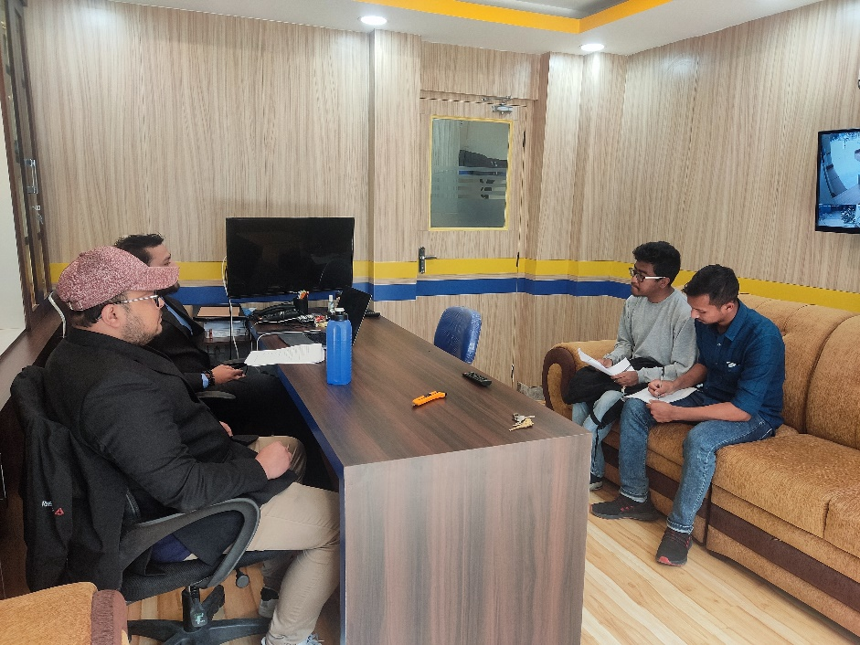

Image 1: Image of interaction with CEO and CTO of the company

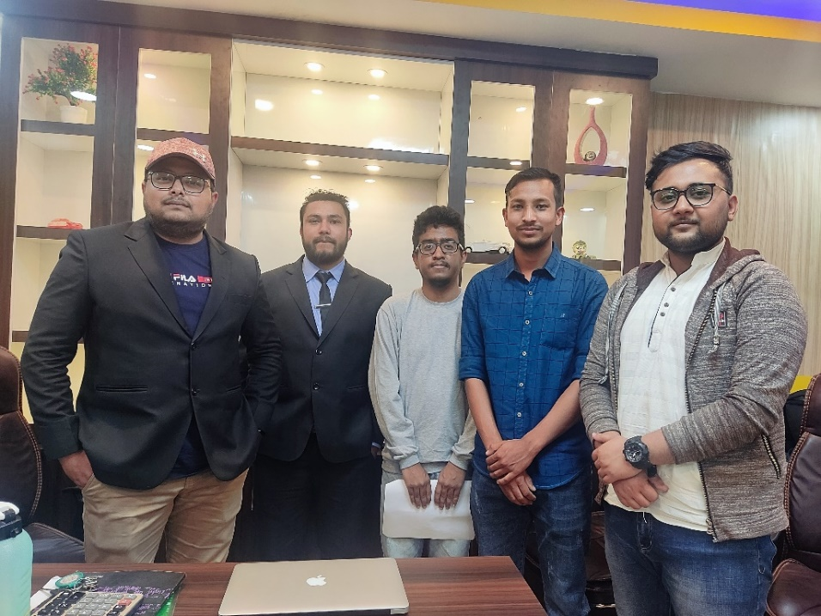

Image 2: Image with the CEO and CTO of the company